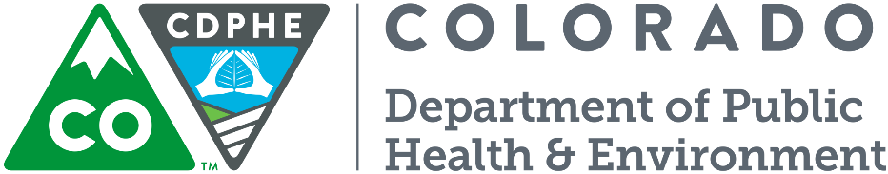
APPENDIX D: Alternative Technology Acceptance Application
Safe Drinking Water Program Implementation Policy #5
4300 Cherry Creek Drive South, B2
Denver, Colorado 80246-1530
CDPHE.WQEngReview@state.co.us, 303-692-6298

Alternative Technology Acceptance Application

In accordance with the Colorado Primary Drinking Water Regulations (Regulation 11), the Water Quality Control Division (Division) may accept alternative filtration technologies to meet the requirements of Regulation 11. The Division also elects to review technologies that do not meet or are not addressed by the State of Colorado Design Criteria for Potable Water Systems. The alternative technology review process does not need to have an associated project to apply however the applicant must have information to support the application (e.g., third party testing reports)

Please note that review and approval for the design of any Public Water System proposing to use an accepted alternative technology will be handled on a case-by-case basis by the Division as required by Section 11.4(1) of Regulation 11.

A. Applicant Information
Applicant / Entity
Representative Name/Title
Address (include City, State, Zip Code)
Email
Phone |  |  |  |  | Fax
B. Alternative Technology Information
Water quality parameter

Please discuss the targeted water quality parameter and the anticipated treatment level of the proposed technology
Alternative technology general description

Please provide a discussion of proposed alternative technology.
Theory and calculations:

Please provide a discussion of the background theory and backup calculations demonstrating how the proposed technology functions, unless such information is specifically documented as proprietary, e.g. the basis of a patent.

Warranty

Please discuss any applicable manufacturer’s warranty and/or performance warranty.
Product specifications:

Please provide model numbers and cut-sheets for all proposed treatment components. Provide specific information for technical components (e.g., flowrates, materials). State any requested treatment removal credits.

Product drawings:

Please provide drawings that fully illustrate the proposed technology and identify any potential safety risks (e.g. cross-connections, bypasses).

Operating conditions, limitations, and testing:

Please provide all operational ranges (e.g., flow ranges); any limitations to the proposed process (e.g., pressure surges); monitoring location, frequency and equipment; alarm set points; required testing parameters including testing frequency, and failure definition.

Raw water quality parameters:

Please state the required influent water quality and any limitations that would impact the effectiveness of the proposed treatment process (e.g., competing ions).
Pretreatment information - required or prohibited processes:

Please state any required pre-treatment processes (e.g., roughing filters) or any treatment processes that would be detrimental (e.g., oxidants) to the effectiveness of proposed alternative technology.

Operator Requirements:

Please discuss the operational demands of the proposed technology; any required training program, and any start-up training programs. Please provide operations & maintenance manuals or standard operating procedures to help determine operator licensing levels from the Colorado operator certification program.

Operating Conditions and Recordkeeping:

Please discuss the operating and maintenance of the proposed technology. Please discuss the ease of operation and any reference materials provided with the equipment. Please discuss any operational records that should be maintained to ensure proper operation. Please discuss any required spare parts that are essential for proper operation.

Cost

Please discuss the cost of the proposed technology including capital cost, annual operating and maintenance cost (e.g., increased monitoring, operator costs, equipment replacements).

C. Supporting Documentation
Potable Water Material Certification:

Part 1.2.11 of the Design Criteria requires that all chemicals and materials that come in contact with water shall be ANSI/NSF Standard 60 and 61 certified, respectively. Several organizations are certified by ANSI for ANSI/NSF Standard 60 and 61 testing including NSF International, Underwriters Laboratories, the Water Quality Association Gold Seal Program and the CSA. Please provide a copy of the certification documentation.

Third Party Challenge Testing Data:

Please provide copies of any challenge testing documentation for the proposed technology. Colorado has reviewed challenge testing results from: the NSF/EPA Environmental Technology Verification (ETV) program, NSF Protocol certification documentation, BioVir testing, and third party challenge testing results with testing protocol explanations.
Other State Acceptances:

Please send any technology acceptance letters from other states that address the proposed technology including the treatment credits granted (e.g. filter log inactivation credit for compliance with the LT2 Rule), any acceptance conditions, and the operating conditions.

Testing Data:  Please submit copies of any pilot testing or case studies related to the technology. The Division prefers data on applications that have similar testing conditions (e.g., water quality, elevation) and of a similar flow rate.  - Reports for pilot studies performed at Public Water Systems  - Case studies of actual operating experience at Public Water Systems and the resulting compliance history. |  |  |  | w
I hereby certify that the information presented above is accurate and complete.
Applicants Legal Representative or Authorized Representative (e.g. Company President, Engineer) |  | Date | Typed Name and Title |  |  | Signature

